Notifications and Subscriptions with ORM stack

Contents

1. Introduction 3
2. Workflow diagram to deploy the stack 3
3. Create stack for Compute cluster 5
4. Plan the Job 7
5. Apply the Job 8
6. Verify in the Console 9
7. Destroy the stack 9

Introduction

In Oracle Cloud Infrastructure (OCI), notifications and subscriptions are essential components of the event-driven architecture that allows users to react to changes and events occurring within the OCI environment. Let's explore what notifications and subscriptions are in OCI:

Notifications:
Notifications in OCI refer to messages that are sent to an endpoint in response to an event or change within the OCI environment. These events can be triggered by various activities, such as changes to resources, service health status, or custom events. Notifications can be delivered to different endpoint types, including HTTPS endpoints, email addresses, and Oracle Functions.

OCI provides the Notification service, which is known as the "Oracle Cloud Infrastructure Notifications service." It is designed to make it easier for users to respond to events and automate workflows based on these events. This event-driven architecture can enhance automation and monitoring capabilities within the OCI environment.

Subscriptions:
Subscriptions in OCI represent the mechanism used to define what events or changes a user or service is interested in receiving notifications for. Subscriptions are associated with a particular topic. A topic is essentially a channel that organizes similar types of events. For example, there might be topics for compute-related events, networking events, database events, etc.

When a user or service subscribes to a specific topic, they express their interest in receiving notifications related to that topic. Subscriptions allow users to customize and filter the notifications they want to receive, which helps in reducing unnecessary noise and allows for more focused event handling.

Workflow diagram to deploy the stack

Below diagram shows how the Terraform Artifact are applied in the OCI. While creating a ORM stack, using terraform deliverables Init, Plan and Apply is the flow to provision the resource in the OCI. We can have the deliverables in any of below.

- GitLab/GitHub Repo
- Bitbucket
- Can be in folder/.zip in the local disk
- Object Storage Bucket
- Can be in compartment
- Oracle provided Template



Create stack for Compute cluster
Go to OCI Console Developer Services Resource Manager Stacks select the compartment Create Stack

My Configuration Folder Browse Select the “Notifications and Subscriptions” folder that contains the terraform Upload

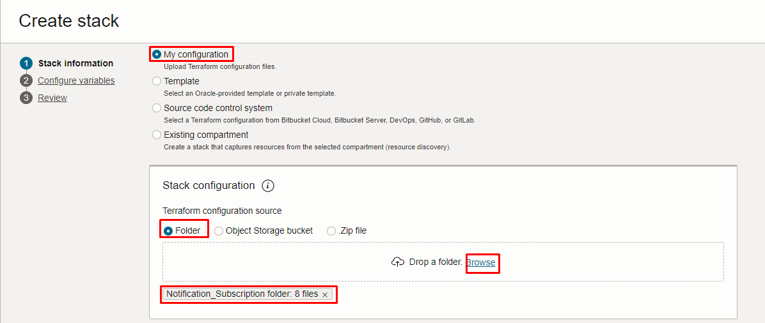
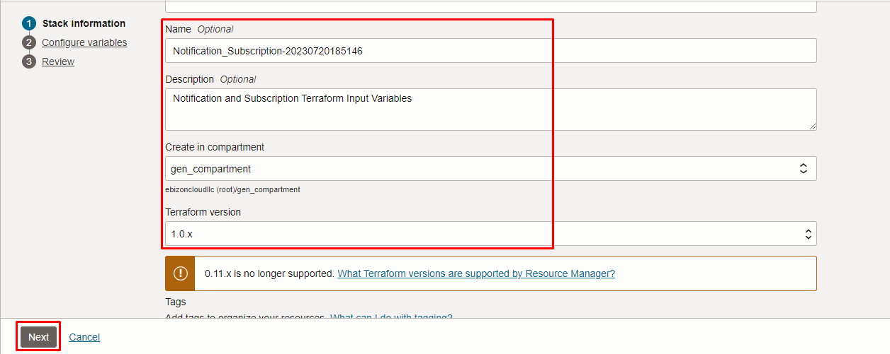
Click “NEXT”
Select the parameters as per the below screen,

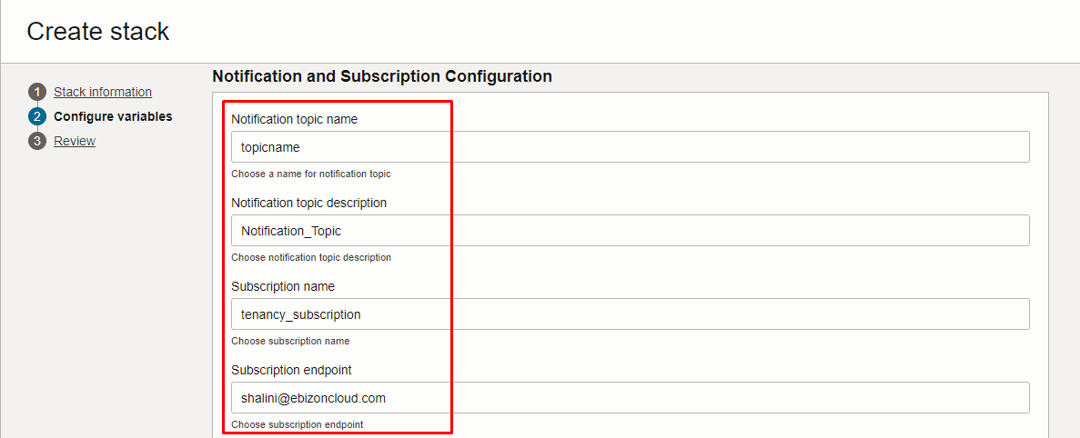
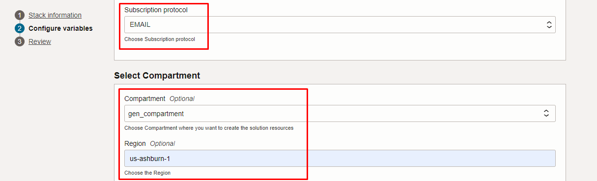
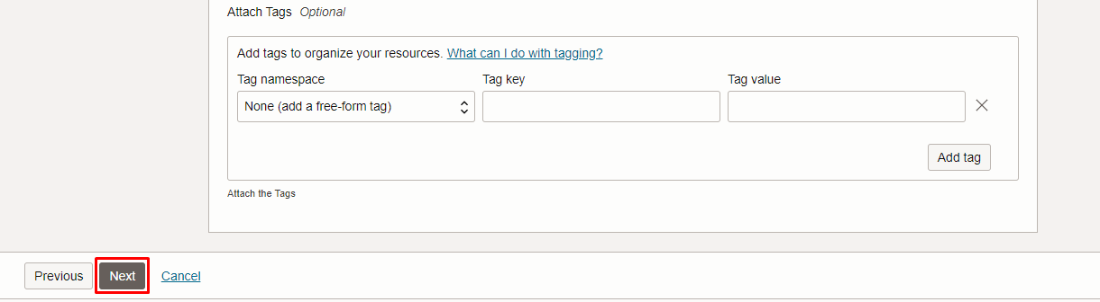
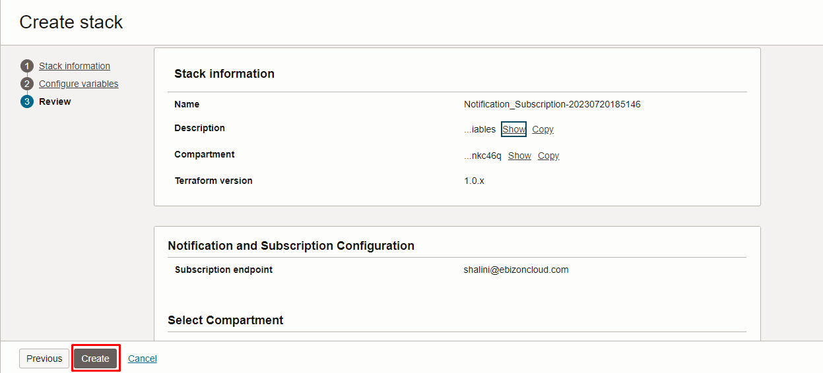
Click “NEXT” Click “CREATE”

Plan the Job

Click the “Plan”
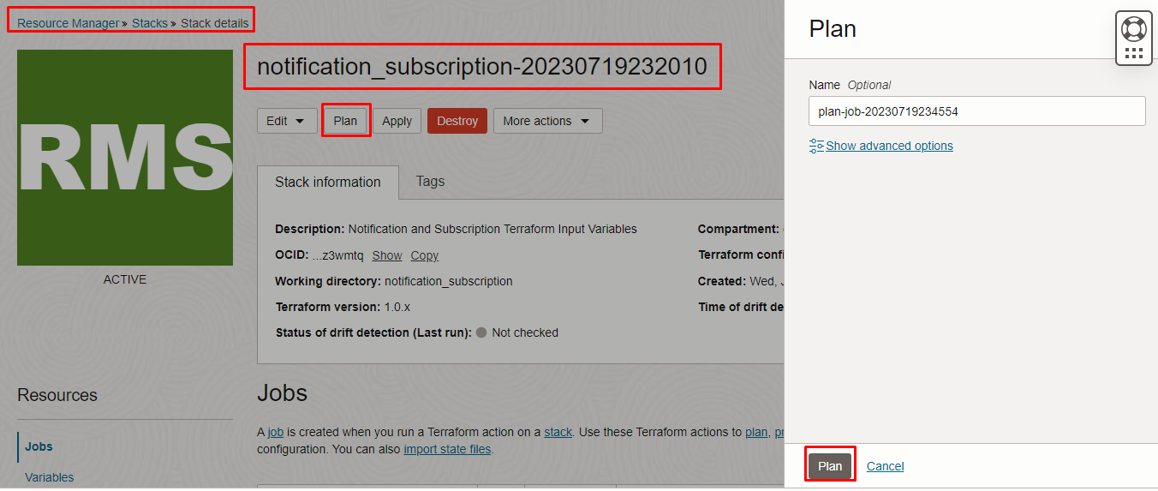
Verify the Plan is successful.

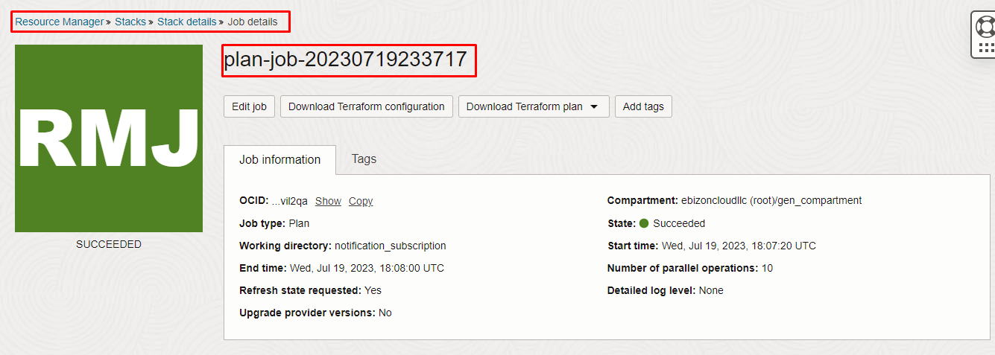
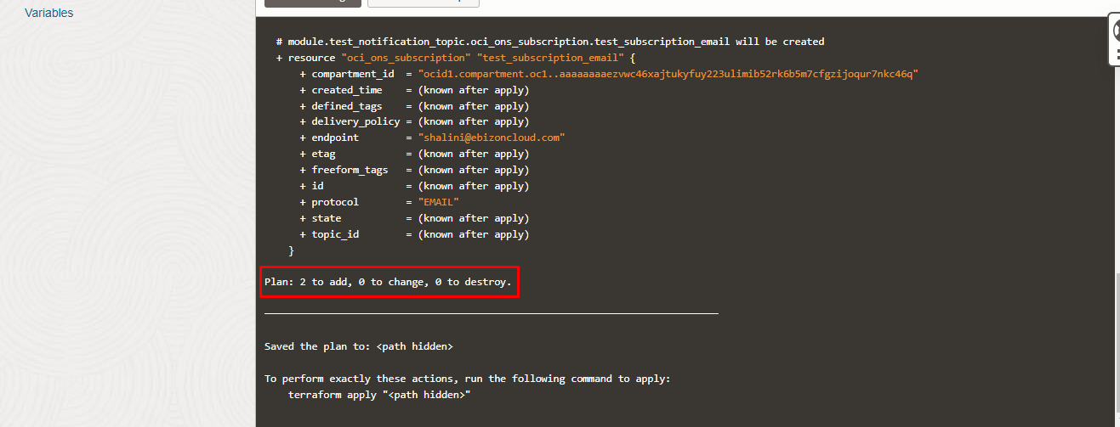

Apply the Job
Once the “plan” is success, now click “Apply”

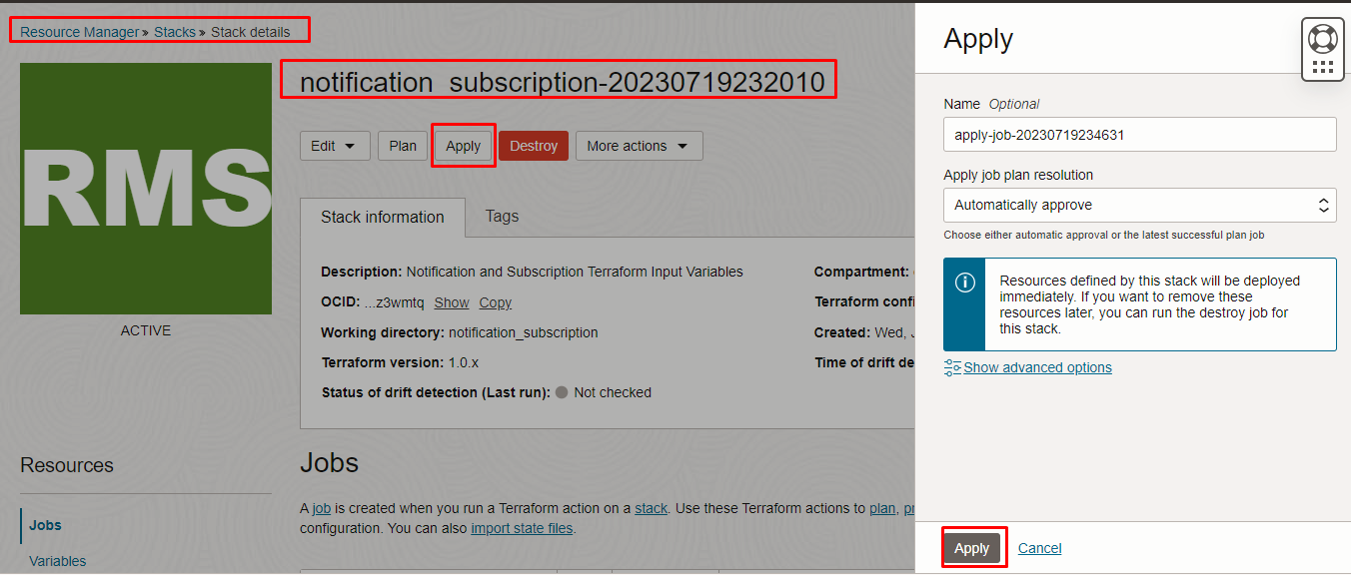
Verify the Apply is successful

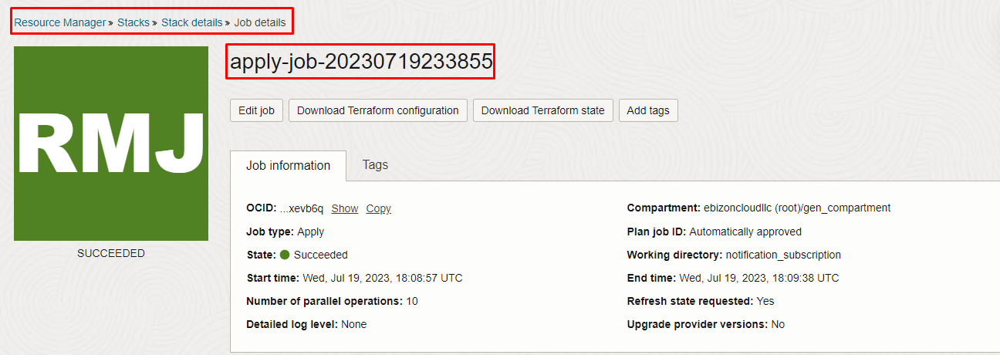
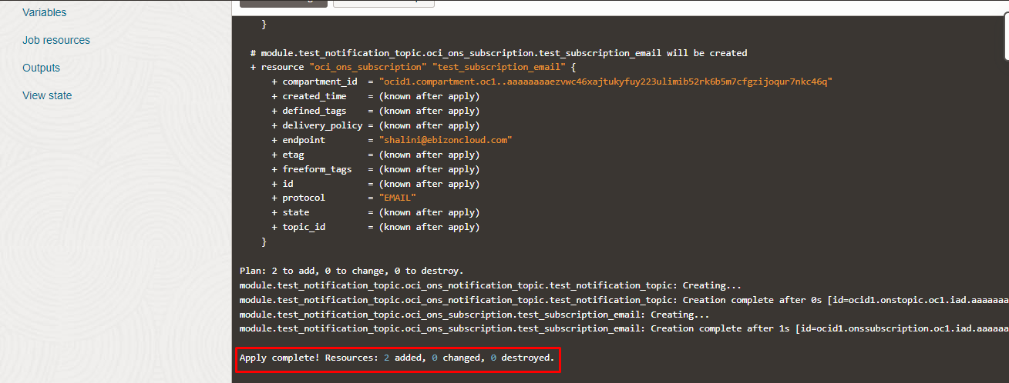

Verify in the Console

Go to OCI Console Developer Services Notifications

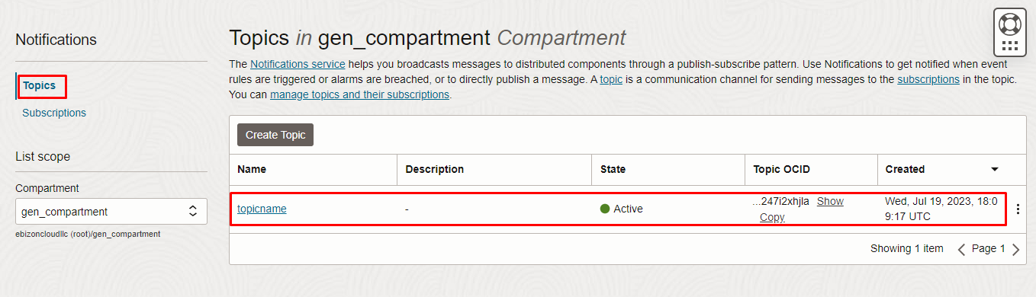
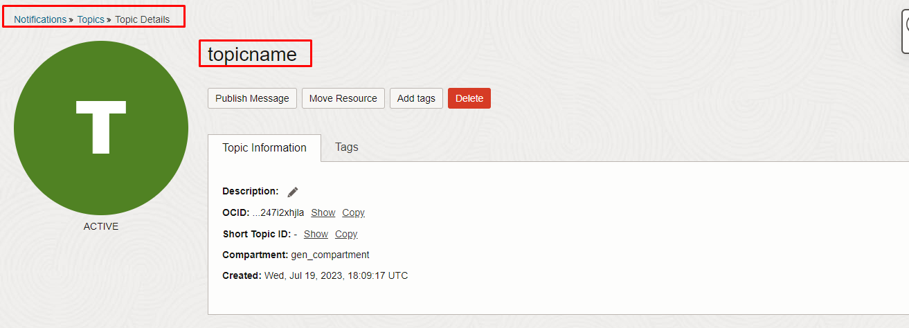
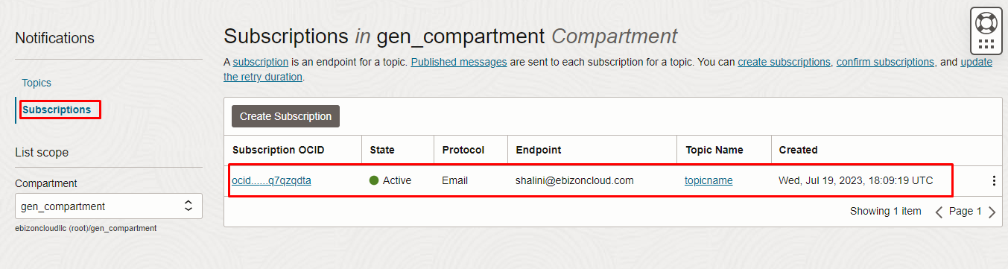
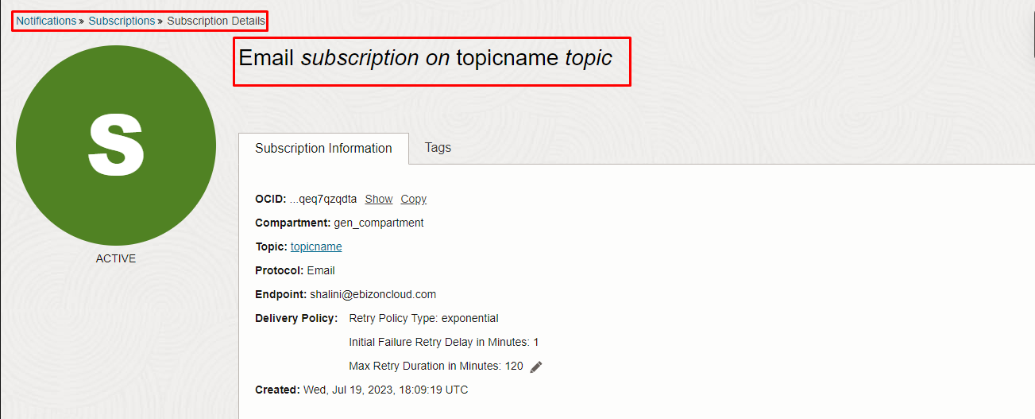

Destroy the stack
Create a destroy job in Resource Manager to release resources associated with a stack and clean up the tenancy. Once destroyed data cannot be recovered from resources.
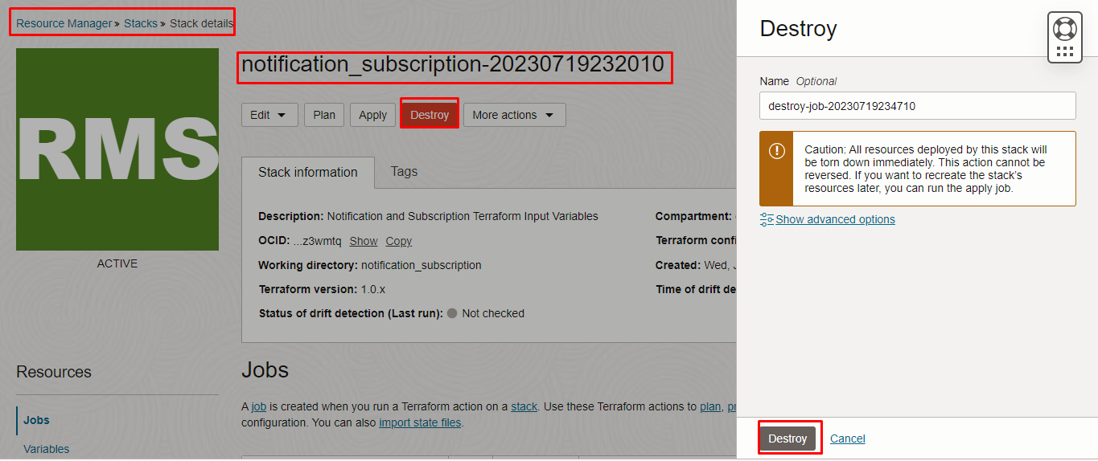
###END###

